Sylmar family knows nature's wrath
By Troy Anderson, Staff Writer
Los Angeles Daily News
Updated: 11/23/2008 02:39:13 AM PST

No one knows Mother Nature's fury like Daniel and Mary Rios.
In a tragic confluence of misfortune, the Rios family has lost three San Fernando Valley homes to natural disasters. First it was the Sylmar Earthquake of 1971. Then the Northridge Earthquake of 1994. And now, the Sayre Fire.
"Was I born under the wrong sign?" asked Mary Rios, 71. "Does my horoscope say, I'm doomed? I know you shouldn't question, but I do question: Why all these times?"
Despite their star-crossed lot in life, the Sylmar couple have kept their religious faith, are
taking their latest bout of bad luck in stride and are considering rebuilding, once again, in the community they love and have called home since 1962.
"I still have my faith in God because he has brought us so many friends, so many people we don't even know who have helped us," Mary Rios said. "One young man sent my husband clothes. We even got calls from people in Kansas asking how they could help. That's what keeps my faith alive."
In the close-knit community at the Oakridge Mobile Home Park, 480 of 608 residences were destroyed in a fire whipped up by what one resident described as the "devil's winds." But amid one of the most destructive fires in the City of Angels' modern history, the Rios family stands out for facing the sheer odds against losing three homes with an indomitable spirit.
Officials at the American Red Cross in Los Angeles and the national office in Washington, D.C., said they have never heard of anyone losing three homes in separate natural disasters.
"I have never heard of anything remotely close to this," said Nick Samaniego, spokesman for the American Red Cross of Greater Los Angeles. "Maybe Southern California is not the best place for this family. Wow, all three homes. That's amazing."
Making some rough calculations, Kenneth S. Alexander, an expert on probability theory at the University of Southern California, placed the odds of the Rios family losing three homes to natural disasters at somewhere between one in 100,000 and one in a million.
"If you take a specific family and ask what's the chance the specific family will have these three catastrophes in their lives, then the chances are extremely small," he said.
Friends of the Rios family say misfortune picked some of the nicest people you could ever meet.
Longtime family friend and Sylmar resident Betty Rios (no relation) said she invited the couple and their three children over for dinner Wednesday night and was amazed at how they were holding up.
"Their faith in God is really strong and that's what is helping them get through this ordeal," Betty Rios said. "It was a bittersweet moment. It was bitter because of what they lost, but the sweet thing is they are still with us."
"And there was comic relief. Even though they have been through this, Mary and her husband can joke about it. They are a very special family."
She said when the family went to sift through the ashes of their home earlier this week, Daniel, 73, asked his son Adrian to see if the tri-tip steak they had put in the refrigerator before the fire was well-done or burnt now.
"People were like, `How can you joke at a time like this?"' Betty said. "He said, `I have a key to the house. Anybody want a free house?' He was holding it up."
Victims of natural disasters usually go through several stages following their loss, Samaniego said.
"It sounds like they probably haven't hit the disillusionment stage yet," he said. "But maybe they have a strong support network.
"Their faith is certainly a strong component. You wish every family has some strength like that to draw upon. ... It's mind-blowing to me to hear they have gone through this three times and yet their spirits are so high."
Adrian, a 40-year-old computer engineer who lives in Pasadena with his wife, said he was surprised by his parents' good spirits, but wishes he could take their place.
"I go through cycles of being upset, being sad and feeling helpless that I can't do more, that I can't save them," he said while visiting the ruins of the mobile home park. "My mom is religious, but I question that. Where was God Saturday night? Why wasn't he helping my family?"
Daniel, who was born in Los Angeles, and Mary, a native of Topeka, Kan., have lived in Sylmar since 1962. Daniel spent 30 years working for the city of Los Angeles as a scale master and gardener in the Sanitation Bureau, retiring in 1994. Mary, a retired quality specialist with General Dynamics, still works at the company part time.
Their first encounter with an L.A. natural disaster occurred on Feb. 9, 1971, when a magnitude-6.6 earthquake struck the Sylmar area. The temblor, which Mary mistook for a bomb detonation, knocked their house a foot-and-a-half off its foundation.
"I was ready to go back to Kansas I was so devastated by the situation," she said. "I had never experienced anything like that. I had seen tornadoes. I had seen floods. But I had only seen something like that in the movies. I thought the ground was going to open up and swallow us."
Nevertheless, the couple decided to stay in Sylmar because their children were in private school and they were close to family and friends in the area. They bought another house and later sold it.
Then it happened again.
While living in a rented house in 1994, the magnitude-6.7 Northridge Quake hit, pushing sewer lines up through the floor of the house and rendering it uninhabitable.
At the time, Mary and Daniel had good jobs and weren't ready to abandon L.A.
"We didn't want to leave and start all over again," she said. "He had a lot of years in working for the city. If he left, he wasn't going to get anything, the medical and retirement benefits. I told him, `We're older now.' And sometimes your family keeps you together."
After vacating that house, the family bought a mobile home at Oakridge. Over the years, speculation about how that home might be destroyed became a family joke.
"We kept telling the kids, `We're leaving California. In the next earthquake, we're going to end up in the ocean,"' Mary said. "But an earthquake didn't happen. Something else did."
In case their future neighbors become concerned their community might get hit by a meteor or yet another unforeseen catastrophe, Alexander, the math professor, said the odds are still one in a million.
"From a scientific perspective, there is no real connection between these events," he said. "The fact that one or another tragedy strikes doesn't really alter the odds in these kinds of instances.
"For the most part, these are random events and we can't predict whether they would be unlucky again in the future."
For his part, Daniel isn't so sure about staying in Sylmar.
"Maybe the third one is a charm," he said. "Maybe it's my turn to get on the winning side. As much as I love California, and I'm a native from downtown Los Angeles, I think I would like to move far away where there aren't any earthquakes, fires and other disasters."
But despite their jinxed choice of hometowns, Mary said they probably will stay in Sylmar, and maybe even rebuild their home at Oakridge.
"What can I say?" Mary said. "We have a lot of good friends here. And we don't even look at them as friends. We look at them as family."
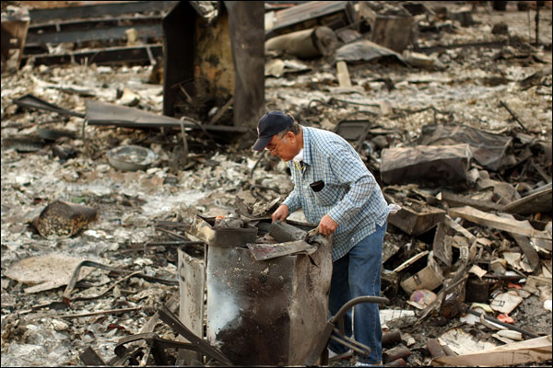
Daniel Rios looks over the charred remains of his home in the Oakridge Mobile Home Park in Sylmar, CA Tuesday November 19, 2008. Residents were allowed to return to their homes Tuesday after the Sayre Fire swept through the area Saturday morning. (Andy Holzman/Staff Photographer)

